Guidelines to format papers for IASS annual symposia

Corresponding AUTHOR*, Forename B. SURNAMEa, Another AUTHORb

*Affiliation of Corresponding Author

Address of Corresponding Author

Email Address of Corresponding Author

a Affiliation of another author if different from Corresponding Author

b Affiliation of another author if different from other authors

# Abstract

This document contains information about the desired format of papers for double-blind peer review and publication. They must be written in English and should be laid out on A4 paper size. **You can produce your paper by simply replacing the contents of this file and saving it as a PDF document** (.pdf file format). Although manuscripts will be peer-reviewed and may be returned to the authors for revision before publication, initial submissions should be made in final form assuming that no revisions shall be necessary. Your abstract should be a single paragraph of text only (no equations, figures or special characters) and should be limited to about 10 to 15 lines of text in 11pt Times New Roman [Style: Normal]. It is this abstract that will appear in the printed proceedings book, and with the metadata of the paper in the online Proceedings on the IASS website.

**Keywords**: Include a list in 9pt Times New Roman [Style: Keywords] of fewer than ten keywords or terms, separated by commas, using nouns or adjective(s)-plus-noun forms that are relatively standard in the field of structural design. (For example: conceptual design, morphology, form finding, optimization, concrete shells, metal spatial structures, membrane structures, earthquake design.)

# 1. Introduction

Manuscripts may be prepared using Microsoft Word, or another convenient editor provided the result follows the format of the file you are just reading and provided the result can be converted to a .pdf file compatible with Adobe Acrobat version 10 or later. Please remember that your files should not be password protected or otherwise locked as the editors may need to make additional minor edits and formatting changes.

If you use Microsoft Word, please make use of *this* template (the file you are just reading). You can produce your manuscript by simply replacing the contents of this file and saving it as a Word document. You may need to adjust the format by specifically applying the Microsoft Word Styles within this document that have been assigned understandable style names, cited here within [square brackets].

**The 2024 IASS symposium invites papers of 4-10 pages in the format of this template Please make sure that the ratio of figures to text is well proportioned. Page limits for papers are strict, and authors violating them will be asked to make edits to reduce their paper lengths as necessary.**

Papers will be published in electronic format as PDF files, so the use of color in figures and photos is possible and encouraged. The symposium proceedings will be available as a collection of PDF files at the time of the Symposium. They will be also electronically issued on the IASS website as part of the series with ISSN number.

# 2. Layout of text

All text, figures and tables should be placed within this template maintaining the provided margins and layout settings. All elements of the paper are to be in the font Times New Roman. This sample file gives the basic layout, and the vast majority of the text, including the text of the Abstract, is in 11pt Times New Roman justified full [Style: Normal].

Please do not modify or write in the headers or footers, except for inserting the names of the authors in the first-page footer as indicated.

The paper should start with the Times New Roman 16pt bold title of the contribution as exemplified above [Style: Title]. The title should have capital letters only at the beginning of the first word and for proper nouns or acronyms. Next are the names of all authors in 11pt [Style: Authors] and in 10pt the affiliation of the authors [Style: Affiliation].

Please mark the corresponding author with an asterisk. Use all capital letters for the surnames of all authors, precede the surname by the forename, and provide full first forenames rather than only initials. Indicate the affiliation of the corresponding author using the asterisk and the affiliations of other authors using superscript lower-case letters a,b,…

The Abstract [Style: Normal] and Keywords [Style: Keywords] follow the authors’ affiliations. The above layout example of Keywords describes their desired characteristics.

All of the numbered first-level headings as well as the unnumbered headings for the Abstract, Acknowledgements and References are in 12pt bold [Style: Heading 1]. Section headings for the first level should be consecutively numbered and should have capital letters only at the beginning of the section title and for proper nouns and acronyms.

## 2.1. Subsections

Headings for second-level subsections are 11pt bold [Style: Heading 2] and are numbered as shown in this example.

### 2.1.1. Third-level subsections

Headings for third-level subsections, if needed, are 11pt italic [Style: Section Heading 3] and are numbered as shown in this example. Please do not use any further levels of subsections.

## 2.2. Equations

Equations ought to appear centered, numbered consecutively as shown in the example.

${\left(x+a\right)}^{n}=\sum_{k=0}^{n}{\left({n \atop k}\right)x^{k}a^{n-k}}$ (1)

Use right tabs at the right margin to justify equation numbers to that edge, and the equation numbers should be in parentheses. Simple equations and assignments, like *ν* = 0, may appear within the text, with variables italicized.

## 2.3. Footnotes

Footnotes should not be used. In the rare case where notes are necessary, please use Endnotes.

## 2.4. Units

Use SI units exclusively. Conversions to imperial units (e.g. feet, inches, pounds, kips) may be provided in parentheses after the SI values are given.

## 2.5. Figures and tables

Tables should be labeled and numbered as “tables”. Figures and photos should all be labeled and numbered as “figures”. The captions are centered, set above the tables and below the figures, using 10pt [Style: Captions] as shown below. As the papers will be disseminated in electronic format, colored photos, pictures and diagrams do not produce any additional cost and are strongly encouraged. However, note that some readers may prefer to print your article for detailed study; it is therefore advisable to design your diagrams such that they are also legible in black and white. Please embed all figures within the document and do not provide them as extra files.

Table 1: This is a typical table caption [with credits and/or references as appropriate]



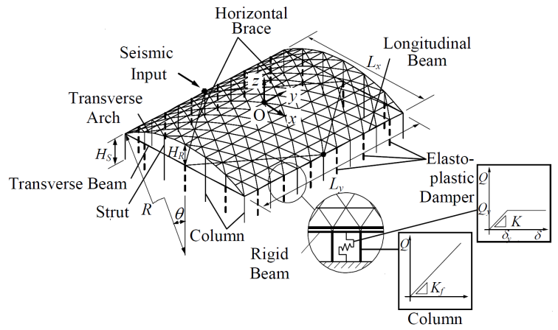

Figure 1: This is a typical figure/photo/table caption [with credits and/or references as appropriate]

# 3. Referencing literature

Use the IEEE citation style (more information [here](http://pitt.libguides.com/citationhelp/ieee)) as shown in the sample reference list at the end of this template. To make it easier for readers to follow reference citations in text, it is recommended that authors refer to previous literature by indicating author names in addition to the numbers in square brackets (e.g. Adriaenssens et al. [1], Chilton [2], or Tibert and Pellgrino [3]). The IEEE style dictates that the references should be numbered and listed at the end of the paper in the order in which they are cited. The reference list should be included at the end of the paper and counts towards the page limits for short and long papers.

# 4. Conclusion: submission of contributions

Papers should be uploaded to the Symposium submission website by the announced deadline. Submissions be made in Microsoft Word (.docx) and/or PDF format(s) following the instructions on the submission website.

# Acknowledgements

This template was adapted from the one used for IASS-IACM 2008 with modifications modeled after templates for recent IASS annual symposia.

# References

[1] S. Adriaenssens, P. Block, D. Veenendaal and C. Williams (eds.), *Shell Structures for Architecture: Form Finding and Optimization*, Routledge, 2014.

[2] J. Chilton, "Heinz Isler's Infinite Spectrum: Form‐Finding in Design," *Architectural Design,* vol. 80, no. 4, pp. 64-71, 2010.

[3] A. G. Tibert and S. Pellegrino, "Review of Form-Finding Methods for Tensegrity Structures," *International Journal of Space Structures,* vol. 26, no. 3, pp. 241-255, 2011.